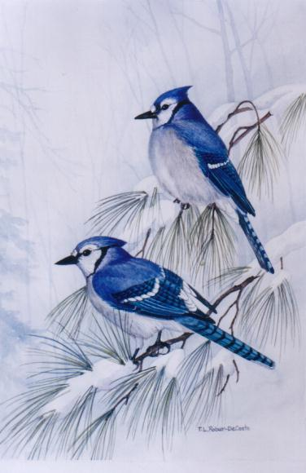

The Autobiography of Harper Lee
By Sara Hussain

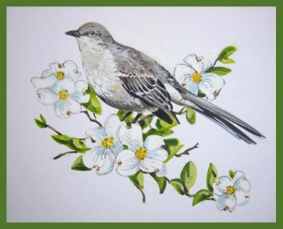

Quick facts:
Birth date: 28 April 1926
Birth place: Monroeville, AL
Religion: Methodist
Occupation: Novelist

Harper Lee was born in Monroeville, AL on April 28, 1926. She was born in a family of 6 with 3 other siblings named Alice Lee, Louise Lee and Edwin Coleman Lee. Her mother was Frances Cunningham Finch and her father, Amasa Coleman Lee, who served as a lawyer in the Alabama legislature from 1926 to 1938. Lee was the youngest out of all her siblings.
She was known to be a tomboy in her early years, wasn’t interested in fashion, but was a very good reader.
As Lee grew older, she attended at Monroe County High school where she grew interest and developed in her literature. Then in 1944, after her graduation, she went to the all- female, Huntingdon College in Montgomery. She wouldn’t spend time in make-up, fashion trends or dating but instead, would spend time studying. Lee then, was a member of the literary honour society and a part of the glee club.
Later on, she transferred to the University of Alabama in Tuscaloosa, where she was known as a loner and an individualist. But she greatly attempted on having a social life and even joined a sorority for a while. But she still pursued her interests and soon became the editor of the school newspaper, the “Rammer Jammer”.
Harper Lee went to 3 other colleges, studying law. But she explained to her family that writing was the best for her, not the law. Then at the beginning of autumn, Lee resumed studying law, but then dropped out by the 1st term. She moved to New York in 1949 to chase her hopes of becoming a writer.
Lee struggled for a few years and worked as an airline reservations clerk in the 1950’s. Until she received a Christmas gift from her friends...a year’s wages!

What was written on the card was:
“You have one year off from your job to write whatever you please. Merry Christmas.”
They knew she had the potential to create something amazing, and they were right.
In July 11, 1960 Harper Lee’s book, ‘To kill a mockingbird’ was published and is now known as one of the best American novels, it has sold over 30 million copies.
Lee has won several prizes for her novel such as the Pulitzer Prize in 1961. Her novel has also been voted ‘Best novel of the century’ by the Library Journal.

