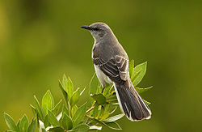

Symbol of the
Mockingbird
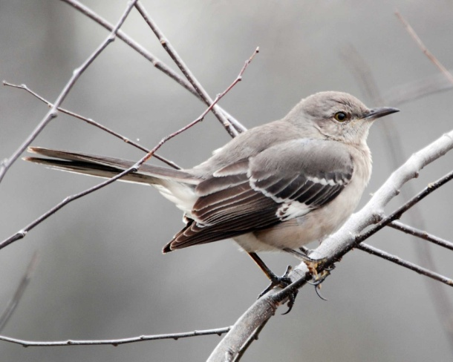

When Jem and Scout received their guns from Atticus, he gave them some advice.
“Shoot all the blue jays you want, if you can hit ‘em, but remember it’s a sin to kill a mockingbird.”(Page 98)
At first they don’t understand this so they ask Miss Maudie who explains to them that the mocking bird has never bothered them and have always sang for them to enjoy. Therefore, killing one would almost become a crime, a sin.
In this story, the Negro people are being referred to as the Mockingbirds. In earlier times and still in the 1930’s, they helped the white people with settlement into the country. They built houses, railways, bridges, etc. Yet they were still treated poorly.
The Tom Robinson’s case is an example where Tom helps Mayella Ewell with her chores even when his left arm was badly injured. Then he was accused of striking Mayella violently, something that he didn’t do. ‘To Kill a Mockingbird’.

