Evaluation criteria
Was it an Australian dish?
Yes, I baked meringues which are an Australian dish.
Does it include eggs?
Yes it includes eggs, but I had only used egg whites.
Is it enough for 10 people?
Yes there is plenty for 10, as it is very filling and not many people will have a lot as it is made of sugar.
Did you aerate the eggs?
Yes, I had used an electric mixer and beat it for about 5 minutes.
Did you try in any way to make it look more Australian?
Yes, I had put blue food colouring but unfortunately, it was not very evident once the final product was finished.

Meringues

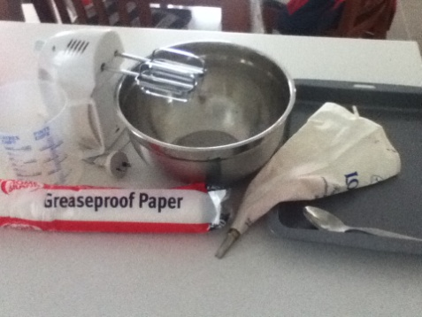 The equipment used.
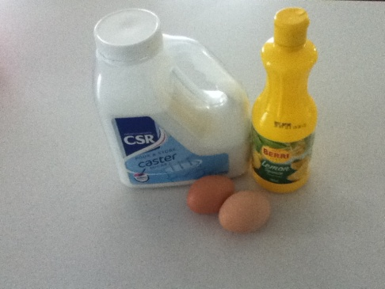 Ingredients used.
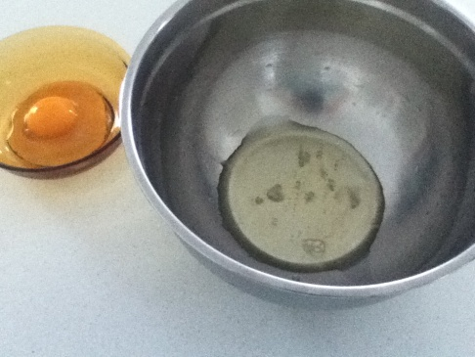 Separate egg whites from yolks.
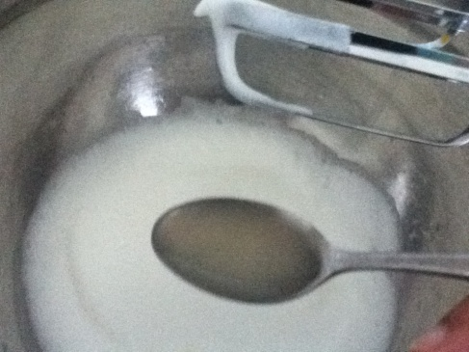 Beat with electric mixer and add lemon.
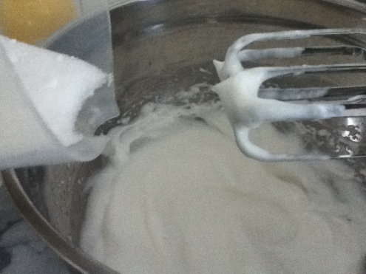 Once eggs are aerated, add sugar a bit at a time while mixing.
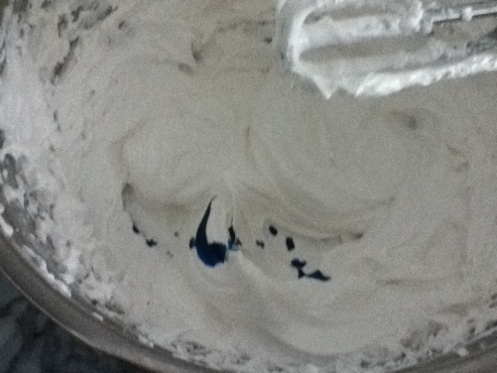 Add food colouring is desired.
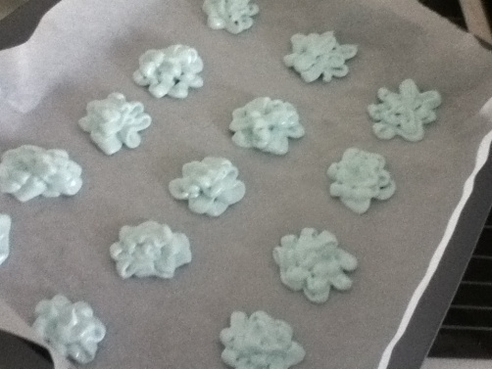 Pipe the mixture into desired shapes [my attempt for a flower].

Place inside the oven at 180 degrees for 15-20 minutes...
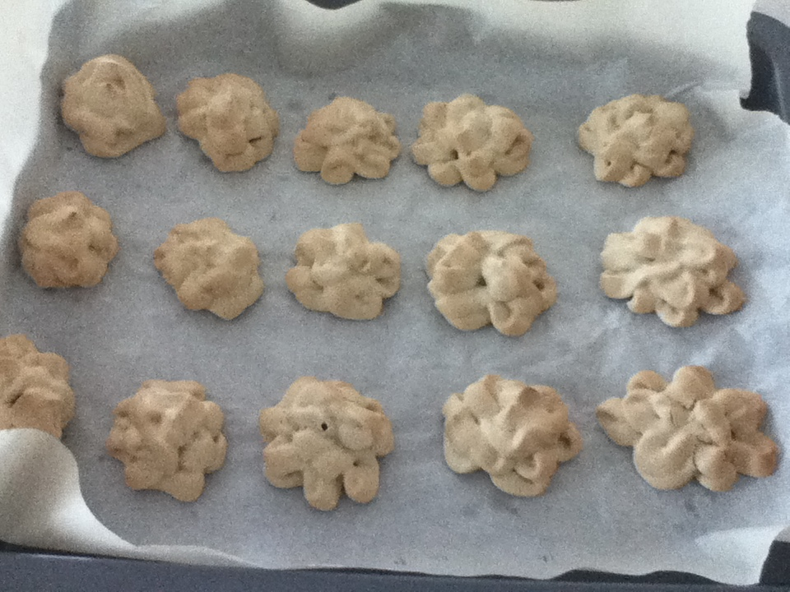
Finished!

