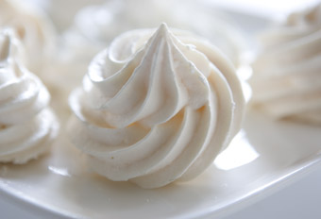
Ingredients:
- Egg whites
- Lemon juice
- Caster sugar
Equipment:
- Bowl: Beat and blend ingredients in.
- Piping bag: Pipe shapes with the mixture.
- Baking tray and baking paper: To place meringues.
- Oven: To bake.
- Spoon: Scoop out the mixture into the piping bag.

Process

- Dissolve: To add a dry ingredient into a liquid and then mixing it to make sure not visible particles are seen in the liquid.
- Beat: To stir rapidly.
- Spoon: An action that involves scooping the ingredients and placing it into something else.
- Bake: To cook food in an oven
- Combine: To mix to ingredients together until they are inseparable.

Recipe
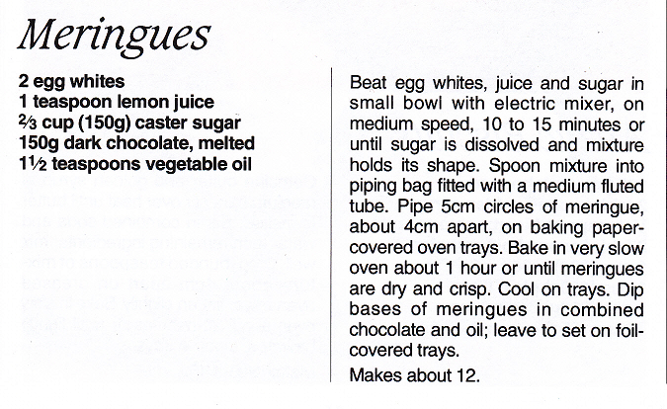

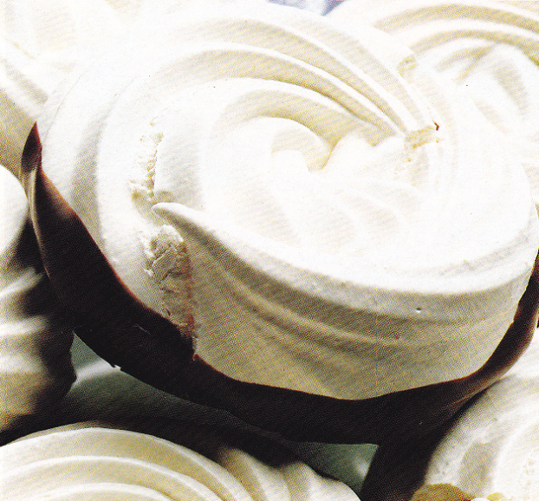

Health & safety procedures
- Make sure all utensils are clean.
- If using any electrical appliances, switch off power after use.
- Keeping personal hygiene, e.g. washing hands, wearing an apron, etc.
- Cover the food if it is not being handled with.
- Once the product is finished, put it inside the fridge to avoid food contamination or bacteria growth.

