Animals in World Biomes activity:
Patagonian Cavy:
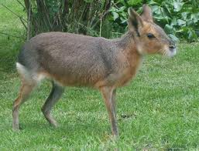
The Patagonian Cavy is also referred to as the Patagonian Mara and is found only in South America. They prefer to live in temperate grassland biomes [like in Patagonia], where temperatures may be around 20 degrees. But they may also live in places with barren soil such as the Monte desert biome. Environments like these are good for them to communicate and to run.

This animal seems very interesting to me in appearance where it looks half-rabbit and half deer. I never knew an animal like this even existed, so I decided to research and learn a bit more about them.

